**Input:**

1. Network: West Jordan (121 nodes, 265 links, length and capacity of link)
2. Home building: 101,102,103

Location of home building: 201,202,203

Location of office building: 301,302,303

Office building: 401,402,403

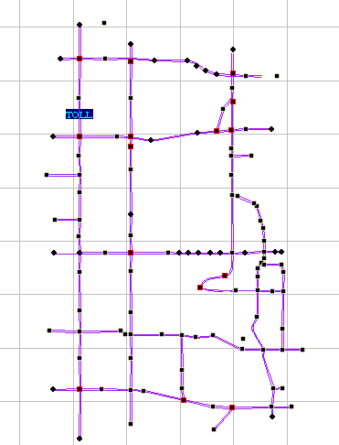

303

302

301

203

202

201

1. Agent (number of transportation agents: 30)

|  |  |  |  |
| --- | --- | --- | --- |
| Building | Transportation agent | Builder | Number of transportation agent |
| 101(home) | 1~15 | 31 | 15 |
| 102(home) | 16~25 | 32 | 10 |
| 103(home) | 26~30 | 33 | 5 |
| 401(office) | 1~10, 16~19, 26 | 34 | 15 |
| 402(office) | 11~13, 20~23, 27, 28 | 35 | 9 |
| 403(office) | 14, 15, 24, 25, 29, 30 | 36 | 6 |

**Output:**

1. Optimal solution:

|  |  |  |
| --- | --- | --- |
| Home Building | Home Location | Agent |
| 101 | 201 | 1~15, 31 |
| 102 | 202 | 16~25, 32 |
| 103 | 203 | 26~30, 33 |

|  |  |  |
| --- | --- | --- |
| Office Location | Office building | Agent |
| 301 | 401 | 1~10, 16~19, 26, 34 |
| 302 | 402 | 11~13, 20~23, 27, 28, 35 |
| 303 | 403 | 14, 15, 24, 25, 29, 30, 36 |

1. **Solving time** by branch and bound algorithm: about 10 minutes, not the exact time

Solving directly: about 5 seconds